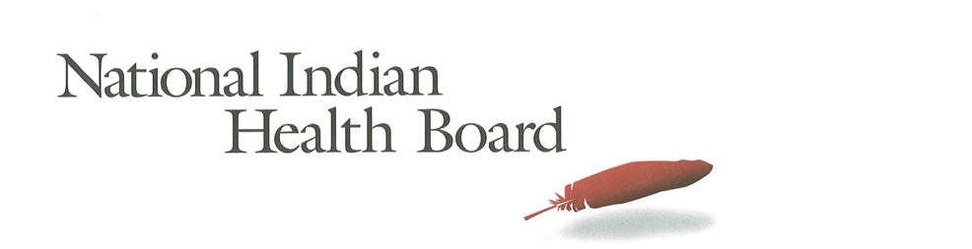

North Carolina

Insurance, Uninsured, and Medicaid: American Indians and Alaska Natives, 2012 and 2017.

This project was supported by a Cooperative Agreement, Grant No. CMS-1MOCMS331623, from the U.S. Department of Health & Human Services, Centers for Medicare & Medicaid Services. The contents provided are solely the responsibility of the authors and do not necessarily represent the official views of HHS or any of its agencies.

North Carolina
Summary Tables: | North Carolina
American Indian and Alaska Native Population 2012 and 2017
2012 | 2017
170,652 | 190,369
American Indian and Alaska Native Uninsured 2012 and 2017
2012 | 2017
32,598 | 26,304
Uninsured Rate 2012 and 2017
2012 | 2017
19% | 14%
Medicaid Enrollment 2012 and 2017
2012 | 2017
55,870 | 59,517
Percent with Medicaid 2012 and 2017
2012 | 2017
33% | 31%

Abstract

This report uses the 2012 to 2017 estimates of the American Community Survey (ACS) to track insurance coverage for American Indians and Alaska Natives (AI/ANs) including uninsurance rates and Medicaid enrollment. From 2012 to 2017, AI/ANs saw large decreases in the number uninsured, decreases in the uninsurance rate, and increases in health insurance coverage, particularly Medicaid coverage (enrollment gains).

In 2017, North Carolina had an AN/AN population of 190,000, with 26,000 uninsured and an uninsurance rate of 14%. 2017 Medicaid enrollment was an estimated 59,000 nearly 4,000 more than 2012. North Carolina saw Medicaid coverage decrease from 33% of the AI/AN population in 2012 to 31% in 2017 as a 20,000 population increase and the decision not to adopt Medicaid eroded the numbers experienced in states that expanded Medicaid.

Research Note: The American Community Survey (ACS) Coverage Question.

The ACS health insurance question asks the respondent to give a separate answer for each member of the household regarding health insurance coverage. The respondent may choose more than one of the answers to the question about what type of coverage they have.
- Employer Sponsored Insurance (ESI)
- Private, paid by individual also known as “non-Group” coverage
- Medicare
- Medicaid
- Tricare, Health care insurance for military and families
- VA, Veteran’s Administration
- IHS coverage-does respondent have ‘access to IHS’

The ACS estimate of those with ‘access to IHS’ is a reasonable estimate of the number of patients of Indian health programs; including both IHS and Tribally-operated programs, not solely IHS-operated programs. However, in several states, including Arizona, the estimate does not seem ‘valid’ as it is not close to the likely number of patients who have access to IHS and/or Tribal health programs. It is advisable that one refer to the IHS Active User population when interpreting state health insurance coverage of AI/ANs. The ACS estimate for those with access to IHS in 2017 was 1.4 million nationally, compared to the 2017 1.6 million IHS Active User Population (that uses a 3 year time frame to determine users).

Note:
The American Community Survey is an annual survey that provides population estimates, including insurance status estimates. AI/ANs are oversampled, but sampling error rate can be very high for smaller populations in some states. These data are from the 2017 survey released in 2018 and accessed using Dataferret January 18, 2019.

Charts

AI/ANs with Health Insurance
2012-2017 Health Insurance Coverage All AIAN
2012-2017 Health Insurance Coverage: With IHS Access
2012-2017 Health Insurance Coverage: Without IHS Access

AI/ANs Uninsured
2012-2017 Uninsured
2012-2017 Uninsured: With Access to IHS
2012-2017 Uninsured: Without Access to IHS

Number of AI/ANs with Medicaid Coverage
2012-2017 Medicaid Enrollment
2012-2017 Medicaid Enrollment: With Access to IHS
2012-2017 Medicaid Enrollment: Without Access to IHS

Percentage AI/ANs with Medicaid Coverage
2012-2017 Percentage AIANS with Medicaid Coverage
2012-2017 Percentage Medicaid AIANs with Access to IHS
2012-2017 Percentage Medicaid AIANs without Access to IHS

AI/AN Medicaid Coverage, by Access to IHS
2012 Total Medicaid, by Percentage with Access to IHS
2017 Total Medicaid, by Percentage with Access to IHS

AI/ANs Population by Access to IHS
2012 Total Population, by Percentage with Access to IHS
2017 Total Population, by Percentage with Access to IHS

The number of AI/ANs with health insurance coverage increased from 138,000 in 2012 to 164,000 in 2017, a 26,000-person increase. Female coverage increased by 16,000, and male coverage increased by 10,000.

Health insurance increased by 1,200 for those with access to IHS, and 24,700 for those without access to IHS. Females saw a greater increase (15,500) than males (9,200), for those without access to IHS.

Note: Nationally, 27% of all AI/ANs have access to IHS and 73% do not have access to IHS. In North Carolina, only 6% of AI/ANs indicate that they have access to IHS.

The number of uninsured AI/ANs decreased by 6,300 from 2012 to 2017; from 32,600 to 26,300. Male uninsured decreased by 4,700 and female uninsured decreased by 1,500.

The number of uninsured AI/ANs with access to IHS increased by 1,100 from 2012 to 2017; from 2,900 to 4,000. This small populations is subject to a large error rate, and caution is advised in interpreting these results.

For those without access to IHS, the increase was 7,400 as females increased by 2,600, and males increased by nearly 5,000.

Medicaid enrollment increased from 55,800 in 2012 to 59,000 in 2017, for a 3,600 total increase. Male enrollment increased by 2,600 while female Medicaid coverage increased by 1,000.

2,000 of the overall Medicaid increase were AI/ANs with access to IHS. Only 1,700 American Indians and Alaska Natives without access to IHS gained Medicaid. Females without access to IHS increased by 400 and males increased by 2,200. This is an unusual finding (that more with IHS gained Medicaid coverage) given the fact that 94% of the states’ AI/AN population does not have access to IHS.

In 2012, 17% of AI/ANs with access to IHS had Medicaid coverage, compared to 34% of those without access to IHS. In 2017, those with IHS access who had Medicaid increased to 30% (a 13 percentage point increase). In 2017, only 31% of those without access to IHS had Medicaid coverage (a 62 percentage point decrease).

The percentage of the total AI/AN population with Medicaid declined from 33% in 2012 to 31% in 2017. Males increased from 31% to 32%, while females decreased from 35% to 31%. The finding bears closer examination to determine its validity, and if valid, the reason for the decrease in female Medicaid coverage.

For those with IHS access, the percentage with Medicaid increased from 17% to 30%--with females increasing from 16 to 36%, and males increased from 18 to 24%. The small population with access to IHS is subject to large error rates, and caution is advised in interpreting these results.

For those without access to IHS, the percentage with Medicaid decreased from 34% to 31% from 2012 to 2017. Males increased from 31% to 32%, and females decreased from 36% to 31% in 2017.

The percentage of AI/ANs with Medicaid who had access to IHS increased from 3% in 2012 to 6% in 2017. The small population with access to IHS is subject to large error rates, and caution is advised in interpreting these results.

In 2012, 5% of the ACS respondents indicated they had access to IHS compared, to 6% in 2017. This small variation is within the margin of error for the estimate. The small population with access to IHS is subject to large error rates and caution is advised in interpreting these results.

