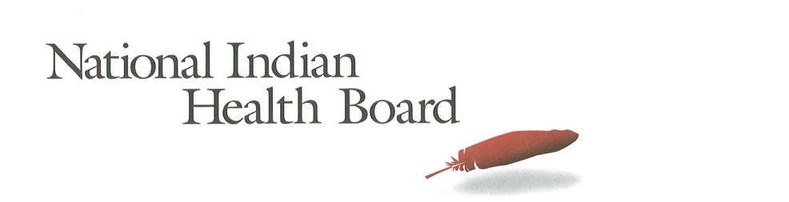

Nebraska

Insurance, Uninsured, and Medicaid: American Indians and Alaska Natives, 2012 and 2017.

This project was supported by a Cooperative Agreement, Grant No. CMS-1MOCMS331623, from the U.S. Department of Health & Human Services, Centers for Medicare & Medicaid Services. The contents provided are solely the responsibility of the authors and do not necessarily represent the official views of HHS or any of its agencies.

Nebraska
Summary Tables: | Nebraska
American Indian and Alaska Native Population 2012 and 2017
2012 | 2017
25,606 | 27,866
American Indian and Alaska Native Uninsured 2012 and 2017
2012 | 2017
6,906 | 5,070
Uninsured Rate 2012 and 2017
2012 | 2017
27% | 18%
Medicaid Enrollment 2012 and 2017
2012 | 2017
9,998 | 8,213
Percent with Medicaid 2012 and 2017
2012 | 2017
39% | 29%
Abstract

This report uses the 2012 to 2017 estimates of the American Community Survey (ACS) to track insurance coverage for American Indians and Alaska Natives (AI/ANs) including uninsurance rates and Medicaid enrollment. From 2012 to 2017 AI/ANs experienced large decreases in the number uninsured, decreases in the uninsurance rate, and increases in health insurance coverage, particularly Medicaid coverage (enrollment gains).

Nebraska had a 2017 AI/AN Population of 27,800—with 5,000 uninsured and an uninsurance rate of 18%. 2017 Medicaid enrollment was an estimated 8,000, nearly 2,000 less than 2012. Nebraska saw Medicaid coverage decrease from 39% of the AI/AN population to 29% in 2017.

Research Note: The American Community Survey (ACS) Coverage Question.

The ACS health insurance question asks the respondent to give a separate answer for each member of the household regarding health insurance coverage. The respondent may choose more than one of the answers to the question about what type of coverage they have.
- Employer Sponsored Insurance (ESI)
- Private, paid by individual also known as “non-Group” coverage
- Medicare
- Medicaid
- Tricare, Health care insurance for military and families
- VA, Veteran’s Administration
- IHS coverage-does respondent have ‘access to IHS’

The ACS estimate of those with ‘access to IHS’ is a reasonable estimate of the number of patients of Indian health programs; including both IHS and Tribally-operated programs, not solely IHS operated programs. However, several states, including Arizona, the estimate does not seem ‘valid’ as it is not close to the likely number of patients who have access to IHS and/or Tribal health programs. It is advisable that one refer to the IHS Active User population when interpreting state health insurance coverage of AI/ANs. The ACS estimate for those with access to IHS in 2017 was 1.4 million nationally, compared to the 2017 1.6 million IHS Active User Population (that uses a 3 year time frame to determine users).

Note:
The American Community Survey is an annual survey that provides population estimates, including insurance status estimates. AI/ANs are oversampled, but sampling error rate can be very high for smaller populations in some states. These data are from the 2017 survey released in 2018 and accessed using Dataferret January 18, 2019.

Charts

AI/ANs with Health Insurance
2012-2017 Health Insurance Coverage All AIAN
2012-2017 Health Insurance Coverage: With IHS Access
2012-2017 Health Insurance Coverage: Without IHS Access

AI/ANs Uninsured
2012-2017 Uninsured
2012-2017 Uninsured: With Access to IHS
2012-2017 Uninsured: Without Access to IHS

Number of AI/ANs with Medicaid Coverage
2012-2017 Medicaid Enrollment
2012-2017 Medicaid Enrollment: With Access to IHS
2012-2017 Medicaid Enrollment: Without Access to IHS

Percentage AI/ANs with Medicaid Coverage
2012-2017 Percentage AIANS with Medicaid Coverage
2012-2017 Percentage Medicaid AIANs with Access to IHS
2012-2017 Percentage Medicaid AIANs without Access to IHS

AI/AN Medicaid Coverage, by Access to IHS
2012 Total Medicaid, by Percentage with Access to IHS
2017 Total Medicaid, by Percentage with Access to IHS

AI/ANs Population by Access to IHS
2012 Total Population, by Percentage with Access to IHS
2017 Total Population, by Percentage with Access to IHS

The number of AI/ANs with health insurance coverage increased from 18,700 in 2012 to 22,800 in 2017, a 4,000-person increase. Female coverage increased by only 300, and males by 3,800.

Health insurance increased by 3,500 for those with access to IHS, 1,900 males and 1,500 females, but just 600 for those without access to IHS.

Note: Nationally, 27% of all American Indians and Alaska Natives have access to IHS and 73% do not have access to IHS. In Nebraska 32% of American Indians and Alaska Natives have access to IHS.

The number of uninsured American Indians and Alaska Natives decreased by 1,800 from 2012 to 2017; from 7,000 to just 5,000. Males and females decreased by about 900 each.

The number of uninsured AI/ANs with access to IHS decreased by 1,600 from 2012 to 2017; from 3,700 to just 2,100. Females and males decreased by 800 each. For those without access to IHS, the number uninsured declined by only 200, with females’ decline making up nearly all of the decrease in uninsured. These small populations are subject to large error rates and caution is advised in interpreting these results.

Medicaid enrollment decreased from 10,000 in 2012 to 8,200 in 2017. This 2,000 overall decrease is the unwelcome result of the decision not to expand Medicaid. Nebraska now plans to expand Medicaid in 2019. Male enrollment declined by 1,000, and female Medicaid coverage by 900.

Medicaid coverage did increase for American Indians and Alaska Natives with access to IHS; by only 400. There was a decrease of 2,100 for AI/ANs without access to IHS. Females without access to IHS decreased by 1,300, and males decreased by 900.

In 2012, 34% of AI/ANs with access to IHS had Medicaid coverage compared to 41% of those without access to IHS. In 2017 those with IHS access who had Medicaid decreased to 32%--a 2 percentage point decrease. In 2017 29% of those without access to IHS had Medicaid coverage –a 12 percentage point decrease.

The percentage of the total American Indian and Alaska Native population with Medicaid decreased from 39% in 2012 to 29% in 2017 with males declining from 39% to 26% and females from 39% to 34%. Nebraska in one of the few states with such declines in Medicaid.

For those with access to IHS, the overall decrease in enrollment in Medicaid was from 34% to 32%, with males decreasing from 35% to 26% and females increasing from 33% to 38%. The small population is subject to larger error rates, and caution is advised in interpreting these results. For those without access to IHS, the percentage with Medicaid decreased from 41% to 29%--males decreased from 41% to 26%, and females decreased from 41% to 32%.

The percentage of AI/ANs with Medicaid with access to IHS increased from 24% in 2012 to 34% in 2017.

In 2012, 28% of the ACS respondents indicated they had access to IHS compared to 32% in 2017.

