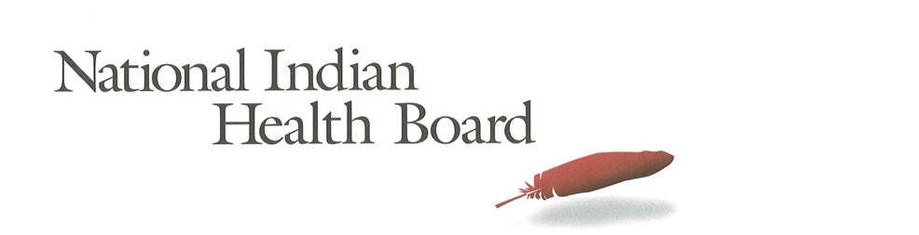

Montana

Insurance, Uninsured, and Medicaid: American Indians and Alaska Natives, 2012 and 2017.

This project was supported by a Cooperative Agreement, Grant No. CMS-1MOCMS331623, from the U.S. Department of Health & Human Services, Centers for Medicare & Medicaid Services. The contents provided are solely the responsibility of the authors and do not necessarily represent the official views of HHS or any of its agencies.

Montana
Summary Tables: | Montana
American Indian and Alaska Native Population 2012 and 2017
2012 | 2017
85,517 | 87,716
American Indian and Alaska Native Uninsured 2012 and 2017
2012 | 2017
31,019 | 22,088
Uninsured Rate 2012 and 2017
2012 | 2017
36% | 25%
Medicaid Enrollment 2012 and 2017
2012 | 2017
31,656 | 36,319
Percent with Medicaid 2012 and 2017
2012 | 2017
37% | 41%

Abstract

This report uses the 2012 to 2017 estimates of the American Community Survey (ACS) to track insurance coverage for American Indians and Alaska Natives including uninsurance rates and Medicaid enrollment. From 2012 to 2017, AI/ANs experienced large decreases in the number uninsured, decreases in the uninsurance rate, and increases in health insurance coverage, particularly Medicaid coverage (enrollment gains).

In 2017, Montana had an AI/AN population of 87,700, with 22,000 uninsured and an uninsurance rate of 25%. Although this decreased from 36% uninsured in 2012, Montana maintains one of the highest uninsurance rates in the nation, despite recent success. 2017 Medicaid enrollment was an estimated 36,000—nearly 5,000 more than 2012. Montana saw Medicaid coverage increase from 37% of the AI/AN population to 41% in 2017.

Research Note: The American Community Survey (ACS) Coverage Question.

The ACS health insurance question asks the respondent to give a separate answer for each member of the household regarding health insurance coverage. The respondent may choose more than one of the answers to the question about what type of coverage they have.
- Employer Sponsored Insurance (ESI)
- Private, paid by individual also known as “non-Group” coverage
- Medicare
- Medicaid
- Tricare, Health care insurance for military and families
- VA, Veteran’s Administration
- IHS coverage-does respondent have ‘access to IHS’

The ACS estimate of those with ‘access to IHS’ is a reasonable estimate of the number of patients of Indian health programs; including both IHS and Tribally-operated programs, not solely IHS-operated programs. However, several states, including Arizona, the estimate does not seem ‘valid’ as it is not close to the likely number of patients who have access to IHS and/or Tribal health programs. It is advisable that one refer to the IHS Active User population when interpreting state health insurance coverage of AI/ANs. The ACS estimate for those with access to IHS in 2017 was 1.4 million nationally, compared to the 2017 1.6 million IHS Active User Population (that uses a 3-year time frame to determine users).

Note:
The American Community Survey is an annual survey that provides population estimates, including insurance status estimates. AI/ANs are oversampled, but sampling error rate can be very high for smaller populations in some states. These data are from the 2017 survey released in 2018 and accessed using Dataferret January 18, 2019.

Charts

AI/ANs with Health Insurance
2012-2017 Health Insurance Coverage All AIAN
2012-2017 Health Insurance Coverage: With IHS Access
2012-2017 Health Insurance Coverage: Without IHS Access

AI/ANs Uninsured
2012-2017 Uninsured
2012-2017 Uninsured: With Access to IHS
2012-2017 Uninsured: Without Access to IHS

Number of AI/ANs with Medicaid Coverage
2012-2017 Medicaid Enrollment
2012-2017 Medicaid Enrollment: With Access to IHS
2012-2017 Medicaid Enrollment: Without Access to IHS

Percentage AI/ANs with Medicaid Coverage
2012-2017 Percentage AIANS with Medicaid Coverage
2012-2017 Percentage Medicaid AIANs with Access to IHS
2012-2017 Percentage Medicaid AIANs without Access to IHS

AI/AN Medicaid Coverage, by Access to IHS
2012 Total Medicaid, by Percentage with Access to IHS
2017 Total Medicaid, by Percentage with Access to IHS

AI/ANs Population by Access to IHS
2012 Total Population, by Percentage with Access to IHS
2017 Total Population, by Percentage with Access to IHS

The number of AI/ANs in Montana with health insurance coverage increased from 54,000 in 2012 to 65,000 in 2017. This 11,000 increase included 6,500 males and 4,600 females.

The increase for AI/ANs without access to IHS was 11,000: 6,000 males and 5,000 females.

The number of Uninsured AI/ANs s in Montana decreased from 31,000 in 2012 to 22,000 in 2017—a 9,000 person decline. Uninsured males declined by 5,200 compared to a 3,700 decrease for females.

The number of uninsured AI/ANs with access to IHS declined by 6,500 from 2012 to 2017 and the number without access to IHS declined by 2,400. Although 57% of all AI/ANs in Montana have access to IHS (see below), it appears Indian health programs have had greater success enrolling patients in health insurance for their population that for those without access to IHS.

Medicaid enrollment increases by 4,600 from 2012 to 2017; from 31,600 to 36,200. The male increase was 3,800 compared to just 800 for females.

Medicaid

Medicaid enrollment increased by 2,000 for those American Indians and Alaska Natives with access to IHS compared to 2,600 for those without access to IHS. The male and female increases were similar for those with access to IHS, but males increase far exceeded the female increase for those without access to IHS.

Medicaid coverage, as a percentage of those with access to IHS increased from 32% to 47%, a 15 percentage point increase, far larger than the 4% increase (from 40 to 44%) for those without access to IHS.

In 2017 Medicaid coverage extended to 41% of Montana’s AI/AN population, compared to just 37% in 2012. Male enrollment increased from 31% to 39% and females increased (statistically no change) from 42% to 43%.

Medicaid coverage for those with access to IHS increased from 32% to 40% in 2017; males from 32 to 39%, and females from 31 to 41%. For those without access to IHS Medicaid experienced an unexpected decline from 47% to 44% with females accounting for all of the decline as coverage slipped from 62% in 2012 to just 46% in 2017. Caution is advised in interpreting these estimates due to the smaller population size.

The percentage of the 2017 AI/AN population with Medicaid (55%) was essentially unchanged between 2012 (56%) and 2017.

The percentage of the total AI/AN population with access to IHS decreased from 66% in 2012 to 57% in 2017. This large of a change deserves further examination. In some cases, non-sampling error may result from a respondent not understanding the coverage question and may not understand that one can have access to IHS and Medicaid coverage.

