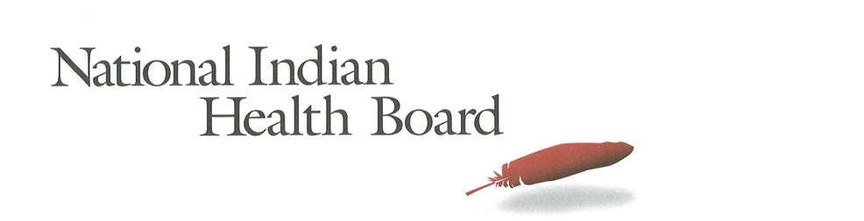

Maryland

Insurance, Uninsured, and Medicaid: American Indians and Alaska Natives, 2012 and 2017.

This project was supported by a Cooperative Agreement, Grant No. CMS-1MOCMS331623, from the U.S. Department of Health & Human Services, Centers for Medicare & Medicaid Services. The contents provided are solely the responsibility of the authors and do not necessarily represent the official views of HHS or any of its agencies.

Maryland

Summary Tables: | Maryland
American Indian and Alaska Native Population 2012 and 2017
2012 | 2017
53,399 | 57,908
American Indian and Alaska Native Uninsured 2012 and 2017
2012 | 2017
3,016 | 2,633
Uninsured Rate 2012 and 2017
2012 | 2017
6% | 5%
Medicaid Enrollment 2012 and 2017
2012 | 2017
11,891 | 15,812
Percent with Medicaid 2012 and 2017
2012 | 2017
22% | 27%

Abstract

This report uses the 2012 to 2017 estimates of the American Community Survey (ACS) to track insurance coverage for American Indians and Alaska Natives including uninsurance rates and Medicaid enrollment. From 2012 to 2017 American Indians and Alaska Natives experienced large decreases in the number uninsured, decreases in the uninsurance rate, and increases in health insurance coverage, particularly Medicaid coverage (enrollment gains).

In 2017, Maryland had an American Indian and Alaska Native Population of 58,000 with 2,600 uninsured, and an uninsurance rate of approximately 5%. In 2017, Medicaid enrollment was estimated at 15,800, nearly 4,000 more than what it was in 2012. Maryland saw Medicaid coverage increase from 22% of the American Indian and Alaska Native population to 27% in 2017.

Research Note: The American Community Survey (ACS) Coverage Question.

The ACS health insurance question asks the respondent to give a separate answer for each member of the household regarding health insurance coverage. The respondent may choose more than one of the answers to the question about what type of coverage they have.
- Employer Sponsored Insurance (ESI)
- Private, paid by individual also known as “non-Group” coverage
- Medicare
- Medicaid
- Tricare, Health care insurance for military and families
- VA, Veteran’s Administration
- IHS coverage-does respondent have ‘access to IHS’

The ACS estimate of those with ‘access to IHS’ is a reasonable estimate of the number of patients of Indian health programs; including both IHS and Tribally operated programs, not solely IHS operated programs. However, for several states, the estimate does not seem ‘valid’ as it is not close to the likely number of patients who have access to IHS and/or Tribal health programs. It is advisable that one refer to the IHS Active User population when interpreting state health insurance coverage of American Indians and Alaska Natives. The ACS estimate for those with access to IHS in 2017 was 1.4 million nationally compared to the 2017 1.6 million IHS Active User Population (that uses a 3 year time frame to determine users).

Note:
The American Community Survey is an annual survey that provides population estimates, including insurance status estimates. American Indians and Alaska Natives are oversampled, but the sampling error rate can be very high for smaller populations in some states. These data are from the 2017 survey released in 2018 and accessed using Dataferret on January 18, 2019.

Charts

AI/ANs with Health Insurance
2012-2017 Health Insurance Coverage All AIAN
2012-2017 Health Insurance Coverage: With IHS Access
2012-2017 Health Insurance Coverage: Without IHS Access

AI/ANs Uninsured
2012-2017 Uninsured
2012-2017 Uninsured: With Access to IHS
2012-2017 Uninsured: Without Access to IHS

Number of AI/ANs with Medicaid Coverage
2012-2017 Medicaid Enrollment
2012-2017 Medicaid Enrollment: With Access to IHS
2012-2017 Medicaid Enrollment: Without Access to IHS

Percentage AI/ANs with Medicaid Coverage
2012-2017 Percentage AIANS with Medicaid Coverage
2012-2017 Percentage Medicaid AIANs with Access to IHS
2012-2017 Percentage Medicaid AIANs without Access to IHS

Medicaid Coverage, by Access to IHS
2012 Total Medicaid, by Percentage with Access to IHS
2017 Total Medicaid, by Percentage with Access to IHS

AI/ANs Population by Access to IHS
2012 Total Population, by Percentage with Access to IHS
2017 Total Population, by Percentage with Access to IHS

The number of American Indians and Alaska Natives with health insurance coverage increased from 50,000 in 2012 to 55,000 in 2017, a 5,000-person increase. All of the increase, according to the ACS estimates, comprised males increasing by 5,300.

Very few Maryland AI/ANs have access to IHS and caution is advised in using these estimates.

Health insurance increased by 5,000 for those without access to IHS. Females saw a decrease (357) and males saw an increase (5,000) for those without access to IHS. Caution is advised for this small population.

Note: Nationally, 27% of all American Indians and Alaska Natives have access to IHS and 73% do not have access to IHS. In Maryland, only 1% of American Indians and Alaska Natives have access to IHS. The small population with access to IHS is subject to larger error rates and caution is advised in interpreting results.

The number of uninsured American Indians and Alaska Natives decreased by 400 from 2012 to 2017; from 3,000 to approximately 2,600. Male uninsured increased by 600 and female decreased by 1,000.

All of the change in uninsured was for American Indians and Alaska Natives without access to IHS and results for those with access is too small to be presented here.

Medicaid enrollment increased from 12,000 in 2012 to nearly 16,000 in 2017. This 4,000 overall increase is a welcome result of Medicaid expansion. Male enrollment increased by 1,700 and female Medicaid coverage increased by 2,100.

All of the change in uninsured was for American Indians and Alaska Natives without access to IHS and results for those with access is too small to be presented here.

Medicaid coverage increased from 22% in 2012 to 27% in 2017.

The percentage of the total American Indian and Alaska Native population with Medicaid rose from 22% in 2012 to 27% in 2017 with males unchanged from 23% to 24% and females increasing from 22% to 31%.

Does this require interpretation?

The percentage of American Indians and Alaska Natives with Medicaid who had access to IHS remained unchanged from 1% in 2012 and in 2017. This small population is subject to a large error rate and caution is advised in interpreting these results.

