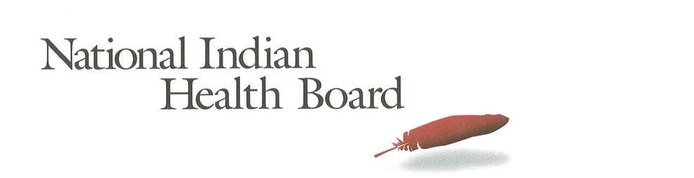

Alaska

Insurance, Uninsured, and Medicaid: American Indians and Alaska Natives, 2012 and 2017.

This project was supported by a Cooperative Agreement, Grant No. CMS-1MOCMS331623, from the U.S. Department of Health & Human Services, Centers for Medicare & Medicaid Services. The contents provided are solely the responsibility of the authors and do not necessarily represent the official views of HHS or any of its agencies.

Alaska

Summary Tables: | Alaska
American Indian and Alaska Native Population 2012 and 2017
2012 | 2017
145,202 | 148,421
American Indian and Alaska Native Uninsured 2012 and 2017
2012 | 2017
51,668 | 37,424
Uninsured Rate 2012 and 2017
2012 | 2017
36% | 25%
Medicaid Enrollment 2012 and 2017
2012 | 2017
48,369 | 59,967
Percent with Medicaid 2012 and 2017
2012 | 2017
33% | 40%

Abstract

This report uses the 2012 to 2017 estimates of the American Community Survey (ACS) to track insurance coverage for American Indians and Alaska Natives (AI/ANs) including uninsurance rates and Medicaid enrollment. From 2012 to 2017 AI/ANs experienced large decreases in the number uninsured, decreases in the uninsurance rate, and increases in health insurance coverage, particularly Medicaid coverage (enrollment gains).

Alaska had a 2017 American Indian and Alaska Native Population of 148,400 with 37,400 uninsured and an uninsurance rate of 25%. 2017 Medicaid enrollment was an estimated 60,000 – nearly 12,000 more than 2012. Alaska saw Medicaid coverage increase from 33% of the American Indian and Alaska Native population to 40% in 2017.

Research Note: The American Community Survey (ACS) Coverage Question.

The ACS health insurance question asks the respondent to give a separate answer for each member of the household regarding health insurance coverage. The respondent may choose more than one of the answers to the question about what type of coverage they have.
- Employer Sponsored Insurance (ESI)
- Private, paid by individual also known as “non-Group” coverage
- Medicare
- Medicaid
- Tricare, Health care insurance for military and families
- VA, Veteran’s Administration
- IHS coverage-does respondent have ‘access to IHS’

The ACS estimate of those with ‘access to IHS’ is a reasonable estimate of the number of patients of Indian health programs; including both IHS and Tribally operated programs, not solely IHS operated programs. However, for several states, the estimates do not seem ‘valid’ as they are not close to the likely number of patients who have access to IHS and/or Tribal health programs. It is advisable that one refer to the IHS Active User population when interpreting state health insurance coverage of AI/ANs. The ACS estimate for those with access to IHS in 2017 was 1.4 million nationally compared to the 2017 1.6 million IHS Active User Population (that uses a 3 year time frame to determine users).

Note:
The American Community Survey is an annual survey that provides population estimates, including insurance status estimates. American Indian and Alaska Native are oversampled, but sampling error rate can be very high for smaller populations in some states. These data are from the 2017 survey released in 2018 and accessed using Dataferret on January 18, 2019.

Charts

AI/ANs with Health Insurance
2012-2017 Health Insurance Coverage All AIAN
2012-2017 Health Insurance Coverage: With IHS Access
2012-2017 Health Insurance Coverage: Without IHS Access

AI/ANs Uninsured
2012-2017 Uninsured
2012-2017 Uninsured: With Access to IHS
2012-2017 Uninsured: Without Access to IHS

Number of AI/ANs with Medicaid Coverage
2012-2017 Medicaid Enrollment
2012-2017 Medicaid Enrollment: With Access to IHS
2012-2017 Medicaid Enrollment: Without Access to IHS

Percentage AI/ANs with Medicaid Coverage
2012-2017 Percentage AIANS with Medicaid Coverage
2012-2017 Percentage Medicaid AIANs with Access to IHS
2012-2017 Percentage Medicaid AIANs without Access to IHS

Medicaid Coverage, by Access to IHS
2012 Total Medicaid, by Percentage with Access to IHS
2017 Total Medicaid, by Percentage with Access to IHS

AI/ANs Population by Access to IHS
2012 Total Population, by Percentage with Access to IHS
2017 Total Population, by Percentage with Access to IHS

The number of AI/ANs with health insurance coverage increased from 93,500 in 2012 to 111,000 in 2017, a 17,000-person increase. Female coverage increased by 7,300 and males by 10,100. Medicaid expansion to childless adults is a large part of the reason for the large increase in male insurance coverage.

Health insurance increased by 3,600 for those with access to IHS and 14,000 for those without access to IHS. In Alaska, 75% of AI/ANs have access to IHS – one of the highest percentages in the country. Still, those indicating they did not have access to IHS increased by larger amounts than those who indicated they did have access to IHS. This deserves further research to see if the large increase in Medicaid and other insurance may have impacted the response to the health insurance coverage question.

Note: Nationally, 27% of all AI/ANs have access to IHS and 73% do not have access to IHS.

The number of uninsured AI/ANs decreased by 14,000 from 2012 to 2017; from 51,000 to 37,000. Males made up most of the decrease (9,000).

The decrease in uninsured for AI/ANs with access to IHS was 15,000 and just 500 for those without access to IHS. The male uninsured decrease was much larger than the female decrease for those with IHS access, 9,400 for males compared to 5,300 for females.

Medicaid enrollment increased from 48,000 in 2012 to 60,000 in 2017. This 11,600 overall increase is a welcome result of Medicaid expansion. Males increased by 7,200 and females by 4,400.

2,500 of the increased Medicaid enrollees were AI/ANs with access to IHS and 9,000 were AI/ANs without access to IHS.

In 2012 33% of AI/ANs with access to IHS had Medicaid coverage compared to 35% of those without access to IHS. In 2017 those with IHS access who had Medicaid increased to 39% (6 percentage point increase). In 2017 46% of those without access to IHS had Medicaid coverage (an 11 percentage point gain).

The percentage of AI/ANs with Medicaid coverage rose from 33% in 2012 to 40% in 2017. Males increased from 30% to 40% and Females from 36% to 41%

For those with access to IHS the overall increase in enrollment in Medicaid was from 33% to 39%, males 32% to 37% and Females 35% to 40%. For those without access to IHS the percentage with Medicaid increased from 35% to 46%; males increased from 24% to 46% and Female percentage was unchanged from 2012 to 2017.

35
AI/ANs with access to IHS represented a smaller share of total AI/ANs overall population in 2017 (75%) than in 2012 (85%). There is likely some non-sampling error in the ACS estimate as most Alaska Natives have access to IHS and this has not changed since 2012. Perhaps some who gained insurance coverage no longer reported they had IHS access; further examination is required.

AI/ANs with access to IHS represented a smaller share of total AI/ANs overall Medicaid population in 2017 (72%) than in 2012 (84%).

