  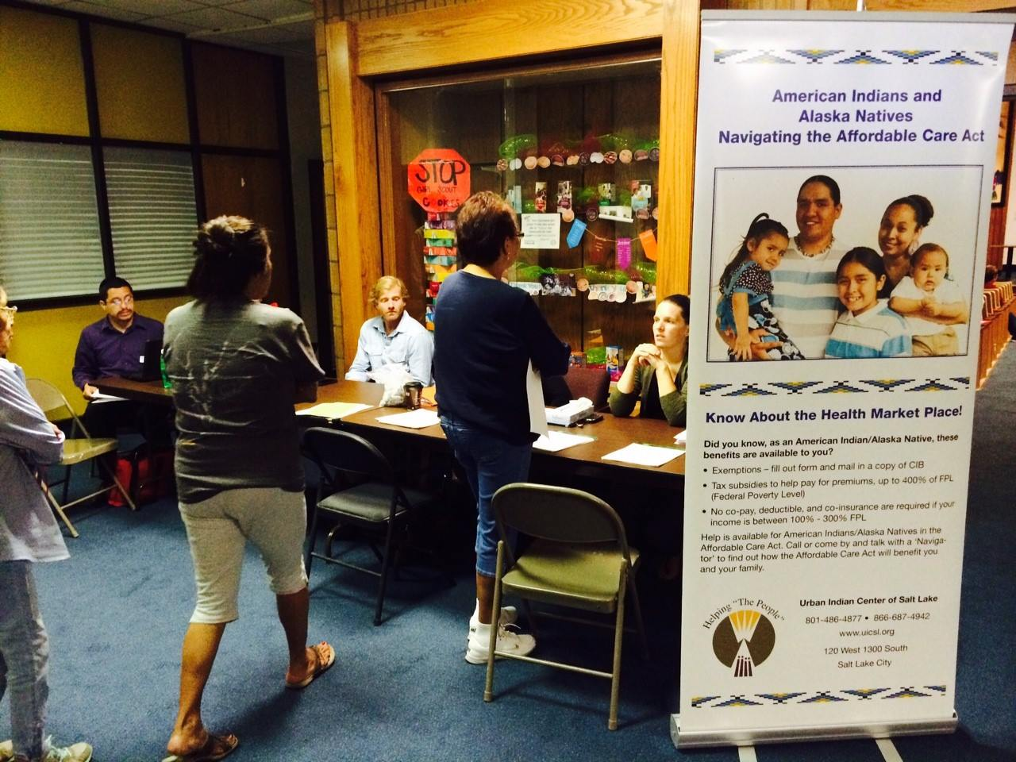
    - 11/01/16
  aca open enrollment 4
  Indian Country & the Affordable Care Act (ACA)
  November 1, 2016 marked the beginning of the fourth Open Enrollment Period for the ACA Health Insurance Marketplace. Even though members of federally recognized Tribes have a special monthly enrollment status, it is important for American Indian and Alaska Native individuals and families to learn about their insurance options. Whether it’s purchasing insurance through the Marketplace or qualifying for Medicaid, knowing that you have quality coverage provides peace of mind. Attend the morning training session to learn more about the ACA, and in the afternoon discover your coverage options with an enrollment specialist.
  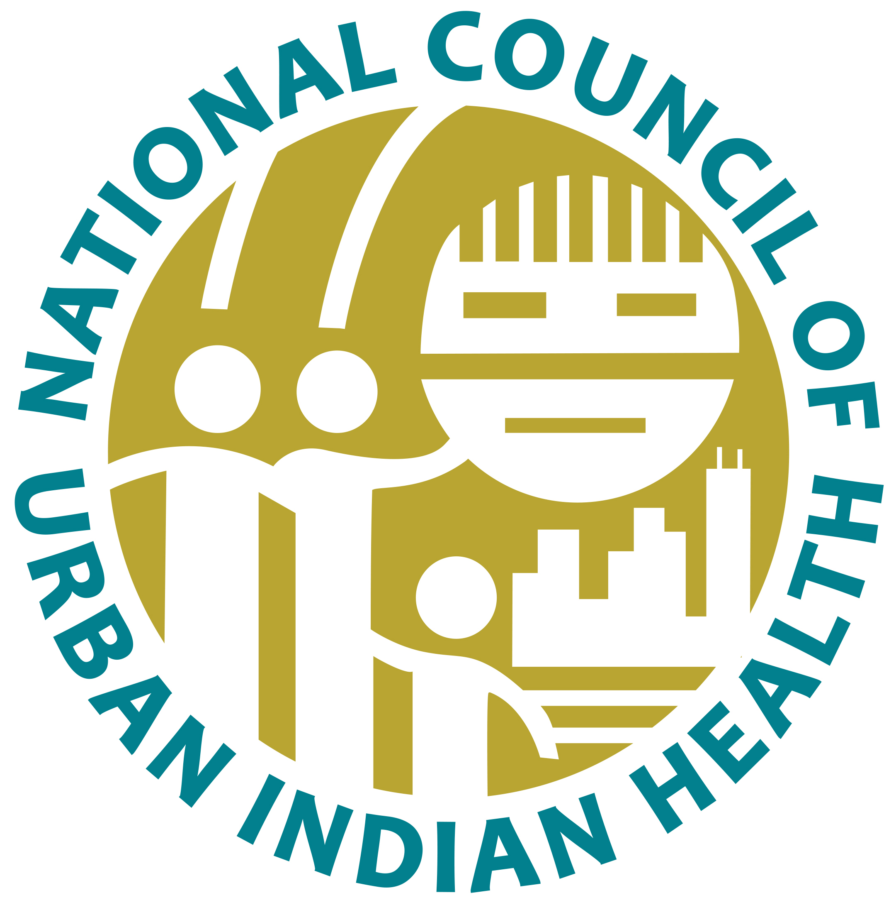
  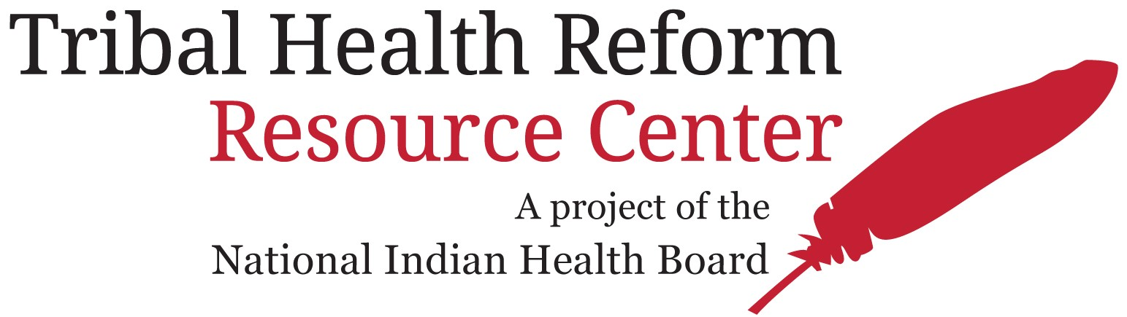
  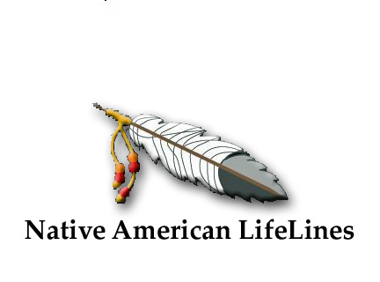
  Tuesday, November 1, 2016
  Native american lifelines 106 W. Clay st. baltimore, md 410-837-2258
  9:00 am—12:00 pm Training: aca overview & Exemption waivers
  1:00 PM—5:00 PM ENROLLMENT: MARKETPLACE PLANS, MEDICAID ELIGIBILITY & EXEMPTION WAIVER APPLICATION
  food served!
  transportation available!
  Call Native American Lifelines at 410-837-2258 to schedule a pick-up.

