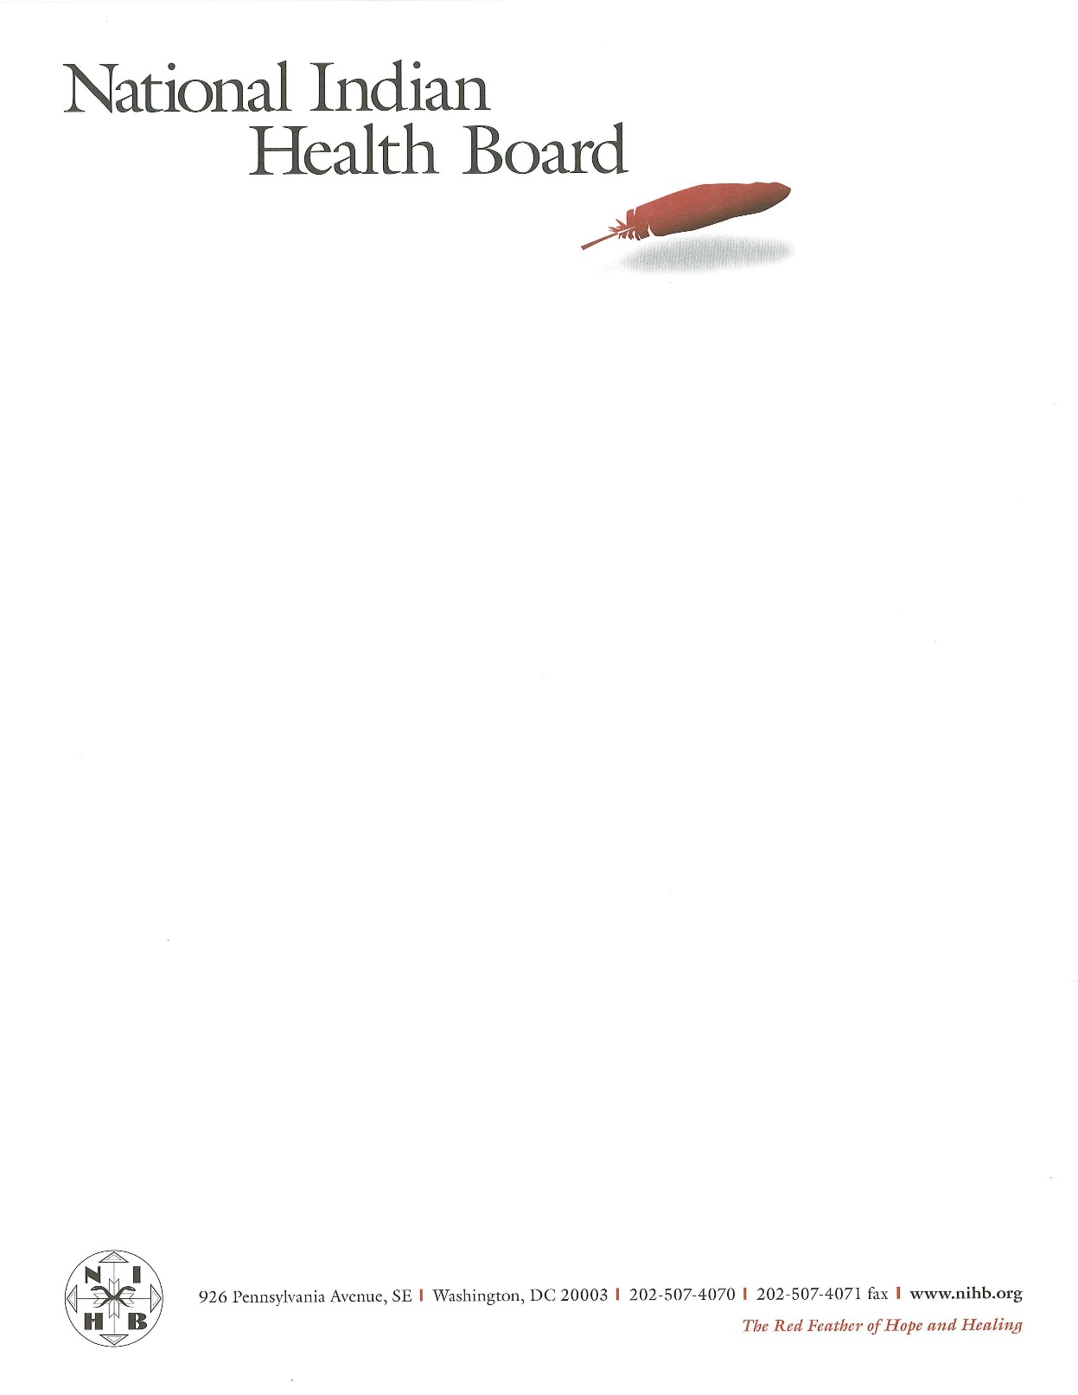

***TRANSMITTED VIA EMAIL***: [tribalgovernmentconsultation@va.gov](mailto:tribalgovernmentconsultation@va.gov)

October 8, 2014

U.S. Department of Veterans Affairs,

Office of Intergovernmental Affairs (075F),

810 Vermont Avenue NW, Suite 915G

Washington DC, 20420

**RE: Notice of Tribal Consultation**

Dear Office of Tribal Relations:

On behalf of The National Indian Health Board (NIHB), we are writing to provide you with the NIHB’s comments and recommendations on the Department of Veteran Affairs (VA) on the Memorandum of Understanding (MOU) between the VA and Indian Health Service (IHS) and how the MOU has affected health care for AI/AN veterans.

Established in 1972, the NIHB is an inter-Tribal organization that advocates on behalf of Tribal governments for the provision of quality health care to all American Indians and Alaska Natives. The NIHB is governed by a Board of Directors consisting of a representative from each of the twelve Indian Health Service (“IHS”) Areas. Each Area Health Board elects a representative to sit on the NIHB Board of Directors. In areas where there is no Area Health Board, Tribal governments choose a representative who communicates policy information and concerns of the Tribes in that area with the NIHB. Whether Tribes operate their entire health care program through contracts or compacts with IHS under Public Law 93-638, the Indian Self-Determination and Education Assistance Act (“ISDEAA”), or continue to also rely on IHS for delivery of some, or even most, of their health care, the NIHB is their advocate.

The NIHB is grateful that the VA chose the Annual Consumer Conference as the site for their consultation session regarding the MOU between the VA and IHS. The consultation session was both productive and informative and opened an honest dialogue between the VA and the American Indians and Alaska Natives (AI/AN) it serves. The NIHB would like to reiterate and expand on the following comments made during the session:

* PTSD Treatment
* Remote Access to Care
* Need for Better Staff & Practices
* Better Communication about MOU
* Diabetes Support

Better PTSD treatment for AI/AN veterans is needed. Many veterans suffer traumatic experiences while in the service and unfortunately they continue to suffer from those experiences long after coming home. We applaud the VA for providing treatment and counselors for AI/AN veterans but this only lasts months to maybe a few years. PTSD is not an easy problem to treat and many AI/AN veterans continue to suffer from it years after returning home. Cultural practices like sweat lodges have been shown to be an effective form of PTSD treatment for some veterans. It would be to the VA’s benefit to research the practice and perhaps initiate a pilot program to test the treatment of PTSD using sweat lodges. Counselors and medication help but medication can sometimes lead to addiction disorders. The NIHB recognizes the challenge ahead for the VA in treating PTSD but hopes that the VA will continue to engage AI/AN veterans on treatment options and remain open minded about cultural practices that may lead to real success down the line.

After leaving military service, many AI/AN veterans return home to the reservation. Reservations are often located away from urban populations and as a result, VA hospitals. For years Veterans had to drive sometimes hundreds of miles just to receive care at a VA facility. With the passage of the Veterans Access, Choice and Accountability Act of 2014, many veterans can now access care at non-VA facilities like tribal clinics. The NIHB applauds this new legislation but support is needed. IHS and tribal facilities are often times ill-equipped to serve veterans on reservations, especially in terms of personnel like counselors. As a result, many veterans are still traveling large distances to access care at VA facilities. These long trips are very expensive and time consuming.

When veterans seek treatment at VA facilities, they are often times treated poorly. Many VA facilities are located in urban cities, staffed by personnel who are not culturally sensitive to AI/AN needs and beliefs. Often times this means that veterans, after having a poor first visit, will not return to the VA for care and encourage others in their community not to seek care as well. This is unacceptable. NIHB strongly recommends that VA staff and personnel receive better training on how to be more sensitive to the needs and practices of AI/AN.

VA and IHS staff need to be better informed about the MOU. NIHB has received numerous reports of staff at IHS hospitals and clinics not being informed about the MOU. In addition, there have been situations where patient medical records are not being shared between IHS and the VA. As a result patients are not receiving the care that they need and prescriptions are not being filled. VA and IHS need to better streamline this process and work together to improve the care that they are both responsible for.

AI/AN have the highest prevalence of diabetes among U.S. racial and ethnic groups.[1] Diabetes often times leads to other complications like increased cardiovascular disease and renal failure. AI/AN serve in the military at a higher rate than all other service members[2] yet there is not enough support and treatment for type 2 diabetes. Heart disease and diabetes are among the four leading causes of AI/AN mortality[3] and if the VA is serious in its commitment to providing health care to AI/AN veterans, more treatment for type 2 diabetes should be made available.

The NIHB appreciates the VA’s consultation session held at the Annual Consumer Conference and is grateful for the opportunity to provide written comments as well. AI/AN veterans deserve access to the best health care and the MOU is a positive step towards meeting that goal but more can be done. We hope that the VA takes the comments made during this consultation under careful advisement and works collaboratively with the IHS to implement some of these changes. Working together, we can all make sure that AI/AN veterans receive the top care they deserve.

Sincerely,

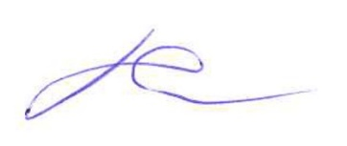

Lester Secatero,

NIHB Chair

1. U.S. Department of Health and Human Services, Indian Health Service, *IHS Special Diabetes Program for Indians, 2011 Report to Congress: Making progress toward a healthier future* (2011).
2. Department of Defense, *Active Duty Master Personnel File*, Reserve Components Common Personnel Data System (2010).
3. Espey DK, Jim MA, Cobb N, et al. *Leading causes of death and all-cause mortality in American Indians and Alaska Natives*. AM. J. Public Health (2014).